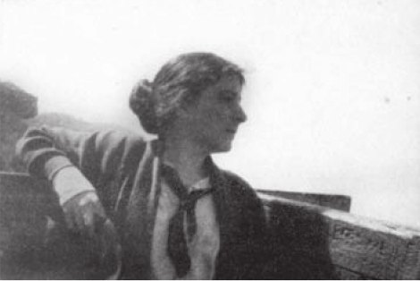

**Harford, Lesbia (1891-1927)**

Lesbia Harford was an Australian writer and political activist. Despite these seemingly complementary roles, she did not view her writing as an instrument for social change, and very few of her poems are overtly political. Harford's poetry is both social and romantic, addressing themes of love, work, and domesticity. Her writing negotiates the world of imperfections with a minimalist style.

Lesbia Venner Keogh (later Harford) was born in Brighton, Melbourne to a middle-class family whose social position slid rapidly into bankruptcy. Her ability to work was limited by a heart condition that restricted her mobility and caused her to tire easily. As an adolescent, Harford began to write poetry.

She attended the University of Melbourne and graduated with a Bachelor of Laws in 1916. During her undergraduate years, Harford, already committed to social justice, became embroiled in anti-war and anti-conscription activism. Rather than pursuing a legal career, she embodied her socialist politics and worked at a clothing factory. She later joined the Industrial Workers of the World.

In 1920 she married Patrick Harford, a fellow IWW member, while working and organizing in Sydney. Their relationship was short-lived, and she returned to Melbourne alone a year later. Throughout her life, Harford was an advocate for free love. She had relationships with men and women while maintaining her independence. Many accounts silence or sensationalise Harford’s sexuality, and little is definitively known. A number of her poems, however, make direct declarations of desire both to men and to women.

When she returned to Melbourne in 1921, Harford worked in the legal field and started a novel that would become *The Invaluable Mystery*. During her final years, Harford’s health rapidly declined. Her heart condition and fragile health led to her death at the age of thirty-six in 1927.

Only a few of Harford’s poems were published during her lifetime. Her identity as an urban Australian woman most likely restricted her opportunities, because contemporary publishers privileged the bush or worker ballad. In 1941, long-term friend Nettie Palmer published a posthumous collection of poetry, *The Poems of Lesbia Harford*. In 1985, a more comprehensive collection of Harford’s poetry was published under the same title.

New interest in reclaiming marginalised writing led to the discovery of Harford’s lost novel *The Invaluable Mystery* in the Australian Archives. Published in 1987, the novel concerns an urban working-class woman and her struggle to survive independently during the Great War. Though the plot seems conventional, the novel illustrates how the home front could be a site of radical change for women.

**List of Works:**

*The Poems of Lesbia Harford* (1941)

*The Poems of Lesbia Harford* (1985)

*The Invaluable Mystery* (1987)

**References and Further Reading:**

Lamb, L. (1983) ‘Lesbia Venner Harford’, *Austrailian Dictionary of Biography* 9: 195-6

Palmer, N, ed. (1941) *The Poems of Lesbia Harford*. Melbourne: Melbourne UP, reproduced online by the University of Sydney <http://purl.library.usyd.edu.au/setis/id/v00033>

Vickery, A. (2009) ‘Lesbia Harford’s Romantic Legacy’, *The Intimate Archive*, published by National Library of Australia, 81-132.